K L UNIVERSITY
FRESHMAN ENGINEERING DEPARTMENT

A Project Based Lab Report On

SMART BANKING MANAGEMENT SYSTEM

SUBMITTED BY:
ID NUMBER NAME
2500031868 R. Mrudula
2500031959 T. Deekshitha
2500032052 M. Jaswanth
2500032056 SK.khasim Jani
basha
2500090318 Hassan Oumar

UNDER THE ESTEEMED GUIDANCE OF Dr. Smitha Kranthi
PROFESSOR



KL UNIVERSITY
Green fields, Vaddeswaram – 522 502 Guntur Dt., AP, India.

DEPARTMENT OF BASIC ENGINEERING SCIENCES



CERTIFICATE

This is to certify that the project based laboratory report entitled “SMART BANKING MANAGEMENT SYSTEM” submitted by Mrudula, Deekshitha , Jaswanth ,Jani Bhasha , Hassan Oumar bearing Regd. No. 2500031868, 2500031959, 2500032052, 25000312056 , 2500090318 to the Department of COMPUTER SICENCE ENGINEERING , KL University in partial fulfillment of the requirements for the completion of a project based Laboratory in “Computational Thinking for Problem Solving (24SC1102)” course in I B Tech I Semester, is a Bonafede record of the work carried out by him/her under my supervision during the academic year 2024 – 2025.

PROJECT SUPERVISOR HEAD OF THE DEPARTMENT Dr. SIREESHA GUNDU Dr. D. HARITHA

ACKNOWLEDGEMENTS

It is great pleasure for me to express my gratitude to our honorable President.

Sri. Koneru Satyanarayana, for giving the opportunity and platform with facilities in accomplishing the project-based laboratory report.
I express sincere gratitude to our Director Dr. A. Jagdeesh for his administration towards our academic growth.
I express sincere gratitude to our Coordinator and HOD-BES Dr. D. Haritha for her leadership and constant motivation provided in successful completion of our academic semester. I record it as my privilege to deeply thank you for providing us with the efficient faculty and facilities to make our ideas into reality.
I express my sincere thanks to our project supervisor Dr. Sireesha Gundu for her novel association of ideas, encouragement, appreciation, and intellectual zeal which motivated us to venture this project successfully.
Finally, we are pleased to acknowledge our indebtedness to all those who devoted themselves directly or indirectly to making this project a success.

2500031868 R. Mrudula
2500031959 T. Deekshitha
2500032052 M. Jaswanth
2500032056 SK.khasim Jani
Basha
2500090318 Hassan Oumar

ABSTRACT

The Smart Banking System is a Python-based application designed to simulate basic banking operations in a secure and efficient manner. The primary objective of this system is to provide users with a simple interface to perform essential banking tasks such as account creation, user authentication, balance inquiry, deposit, withdrawal, and transaction tracking.
This project is developed using fundamental programming concepts including object-oriented programming, file handling, and exception handling. User data is securely stored in a structured format using JSON files, ensuring persistence of account information and transaction history.
The system emphasizes data integrity and security by implementing login authentication mechanisms. It also ensures user-friendly interaction through a menu-driven interface, making it accessible even to users with minimal technical knowledge.
The Smart Banking System serves as a practical implementation of real-world banking processes in a simplified manner. It can be further enhanced by integrating graphical user interfaces, databases, and advanced security features, making it scalable for more complex applications.

INDEX

S.NO | TITLE | PAGE NO
1 | Introduction | 6
2 | Aim of the Project | 7
2.1 | Advantages & Disadvantages | 8
2.2 | Future Implementation | 8
3 | Software & Hardware Details | 8
4 | Data Flow Diagram | 9
5 | Algorithm for each module | 10-11
6 | Implementation | 11-14
7 | Integration and System Testing | 15-16
8 | Conclusion | 16

INTRODUCTION

In today’s digital era, banking systems have become an essential part of everyday life, enabling users to perform financial transactions quickly and securely. With the increasing demand for efficient and user-friendly banking solutions, there is a need to develop systems that simplify banking operations while ensuring data security and accuracy.

The Smart Banking System is a Python-based application developed to demonstrate the core functionalities of a real-world banking system in a simplified environment. This project allows users to create accounts, securely log in, and perform basic banking operations such as depositing money, withdrawing funds, checking account balance, and viewing transaction history.

The system is built using fundamental programming concepts such as object-oriented programming, file handling, and basic authentication techniques. It uses JSON files to store user data, ensuring that all account details and transactions are preserved even after the program is closed.

This project is especially useful for understanding how banking systems operate at a basic level and how programming can be applied to solve real-world problems. It also serves as a foundation for developing more advanced banking applications with graphical interfaces, database integration, and enhanced security features.

AIM

The aim of this project is to develop a Smart Banking System using Python that allows users to perform essential banking operations such as creating an account, logging in securely, depositing and withdrawing money, checking account balance, and viewing transaction history. The system is designed to be simple, efficient, and user-friendly while demonstrating key programming concepts like object-oriented programming, file handling, and basic security features. It also aims to provide a foundational understanding of how real-world banking systems function.

- To develop a banking system using Python
- To enable secure user account creation and login
- To perform basic banking operations (deposit, withdraw, balance check)
- To maintain transaction history
- To store and manage user data using file handling (JSON)
- To apply object-oriented programming concepts
- To create a simple and user-friendly interface
- To understand real-world banking system functionality

ADVANTAGES
- User-Friendly Interface – Easy to use and understand, even for beginners with minimal technical knowledge.
- Efficient Data Management – Stores and manages user data and transactions systematically using file handling.
- Time-Saving – Allows quick banking operations like deposit, withdrawal, and balance checking without manual effort.

DISADVANTAGES
- Limited Security – Basic authentication is used; lacks advanced security features like encryption or multi-factor authentication.
- No Database Integration – Uses file handling (JSON), which is not suitable for large-scale or multi-user systems.
- No Graphical Interface – Operates through a command-line interface, which may not be user-friendly for all users.

FUTURE IMPLEMENTATION
- Graphical User Interface (GUI) – Develop a user-friendly interface using tools like Tkinter or PyQt for better user experience.
- Database Integration – Replace JSON file storage with databases like MySQL or SQLite for efficient handling of large data.
- Web-Based Application – Convert the system into a web application using frameworks like Flask or Django for remote access.
- Mobile Application – Develop a mobile app version for Android/iOS to make the system more accessible.

SYSTEM REQUIREMENTS

SOFTWARE REQUIREMENTS:
  - Python 3.x
  - Any code editor (VS Code / IDLE / PyCharm)
  - JSON for data storage
  - Operating System (Windows/Linux/macOS)

HARDWARE REQUIREMENTS:
  - Processor: Intel i3 or higher
  - RAM: Minimum 4 GB
  - Hard Disk: At least 200 MB free space
  - Input Devices: Keyboard and Mouse
  - Display: Standard monitor

DATA FLOW DIAGRAM

START
|
v
DISPLAY MAIN MENU
(Create Account / Login)
|
v
USER SELECT OPTION
|
+----------------------+
| |
v v
CREATE ACCOUNT LOGIN
| |
v v
ENTER USERNAME ENTER USERNAME
& PASSWORD & PASSWORD
| |
v v
CHECK USER EXISTS VALIDATE CREDENTIALS
| |
| Yes / No | Yes / No
v v
ERROR / SAVE BANKING MENU INVALID LOGIN
ACCOUNT (JSON) (OPERATIONS) |
| | v
+----------------------|------------------ END/RETRY
|
v
-----------------------------------------
| | | |
v v v v
DEPOSIT WITHDRAW BALANCE TRANSACTION
HISTORY
| | | |
v v v v
UPDATE BALANCE + SAVE DATA (JSON FILE)
|
v
BACK TO MENU
|
v
EXIT

ALGORITHM

1. Start
- Initialize program
- Load existing user data from JSON file
2. Display Menu
- Show options: Create Account or Login
3. If Create Account
- Take username and password
- Check if user already exists
- If not, store user data in JSON with balance = 0
- Save data
4. If Login
- Take username and password
- Validate credentials
- If correct, go to banking menu
- Else show error
5. Banking Operations
If login is successful, user can:
- Deposit Money
  - Add amount to balance
  - Save transaction
- Withdraw Money
  - Check balance
  - If sufficient, deduct amount
  - Save transaction
- Check Balance
  - Display current balance
- Transaction History
  - Display all previous transactions
6. Save Data
- After every transaction, update JSON file
7. Exit
- End program

CODE

import json
import os

DATA_FILE = "data.json"

# Load data
def load_data():
if not os.path.exists(DATA_FILE):
return {}
with open(DATA_FILE, "r") as file:
return json.load(file)

# Save data
def save_data(data):
with open(DATA_FILE, "w") as file:
json.dump(data, file, indent=4)

class BankAccount:
def __init__(self, username):
self.username = username
self.data = load_data()

def create_account(self, password):
if self.username in self.data:
print("Account already exists!")
return

self.data[self.username] = {
"password": password,
"balance": 0,
"transactions": []
}
save_data(self.data)
print("Account created successfully!")

def login(self, password):
if self.username in self.data and self.data[self.username]["password"] == password:
print("Login successful!")
return True
print("Invalid credentials!")
return False

def deposit(self, amount):
self.data[self.username]["balance"] += amount
self.data[self.username]["transactions"].append(f"Deposited {amount}")
save_data(self.data)
print(f"Deposited {amount}")

def withdraw(self, amount):
if self.data[self.username]["balance"] >= amount:
self.data[self.username]["balance"] -= amount
self.data[self.username]["transactions"].append(f"Withdrew {amount}")
save_data(self.data)
print(f"Withdrew {amount}")
else:
print("Insufficient balance!")

def check_balance(self):
print("Balance:", self.data[self.username]["balance"])

def transaction_history(self):
print("Transactions:")
for t in self.data[self.username]["transactions"]:
print("-", t)

def main():
print("=== Smart Banking System ===")
username = input("Enter username: ")
account = BankAccount(username)

choice = input("1. Create Account\n2. Login\nChoose: ")

if choice == "1":
password = input("Create password: ")
account.create_account(password)

elif choice == "2":
password = input("Enter password: ")
if account.login(password):
while True:
print("\n1. Deposit\n2. Withdraw\n3. Balance\n4. Transactions\n5. Exit")
opt = input("Choose: ")

if opt == "1":
amt = float(input("Enter amount: "))
account.deposit(amt)

elif opt == "2":
amt = float(input("Enter amount: "))
account.withdraw(amt)

elif opt == "3":
account.check_balance()

elif opt == "4":
account.transaction_history()

elif opt == "5":
break

else:
print("Invalid option!")

if __name__ == "__main__":
main()
INTEGRATION AND SYSTEM TESTING
OUTPUTS
Screen shorts:

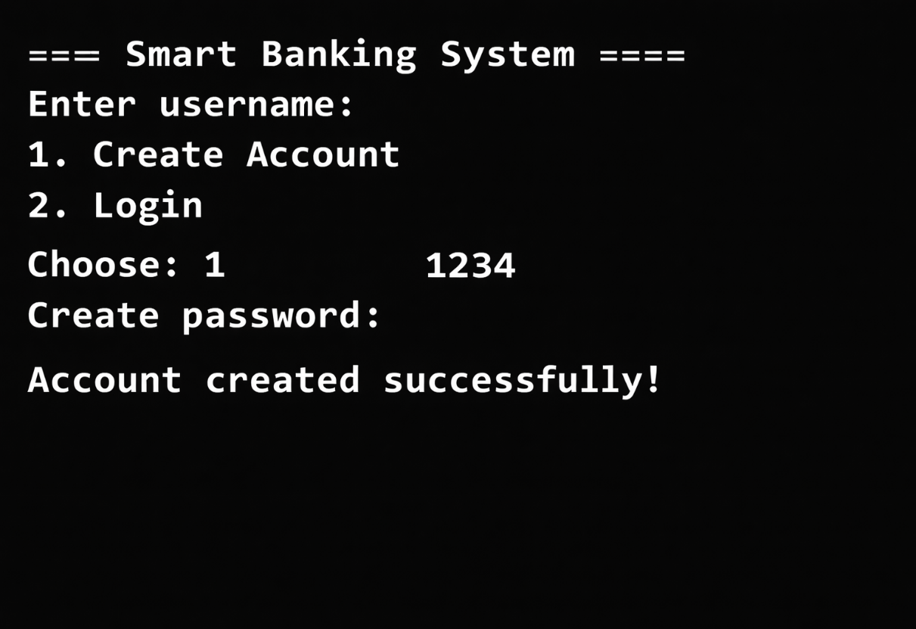

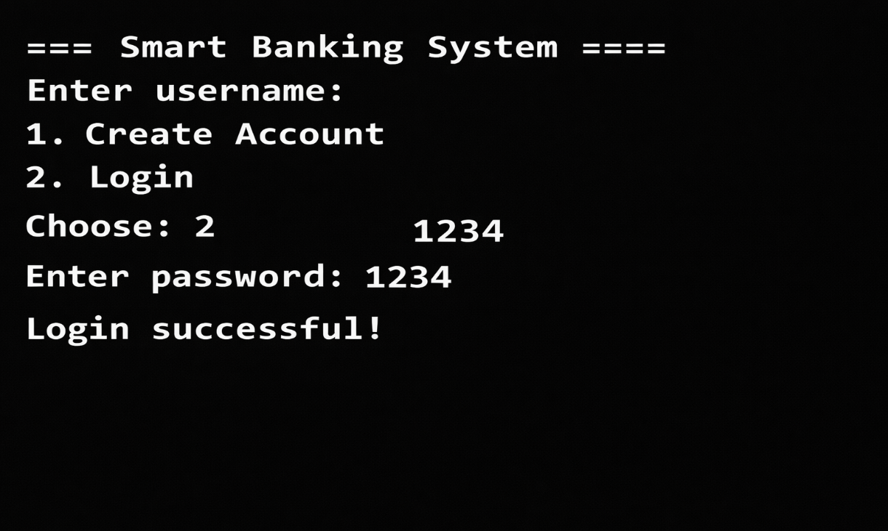
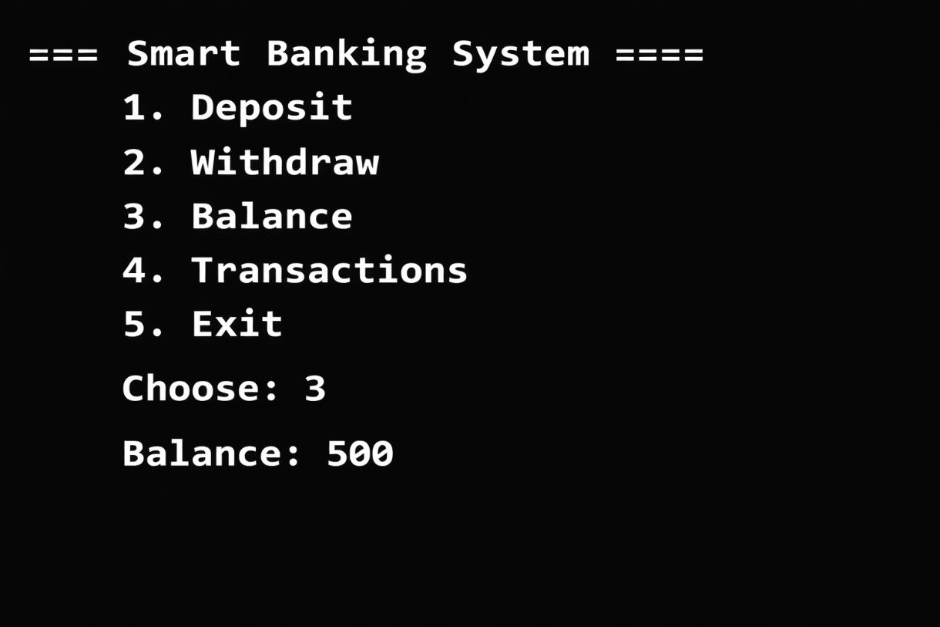



Conclusion:
The Smart Banking System project demonstrates how basic banking operations can be implemented using Python. It allows users to create accounts, securely log in, deposit and withdraw money, check balances, and view transaction history. The system uses a JSON file to store data, making it simple and efficient for managing user information.
Overall, this project helps in understanding file handling, object-oriented programming, and basic user interaction in Python, and it shows how programming can be used to build simple real-world applications like banking systems.

